Student Projects and Research Committee (SPARC)

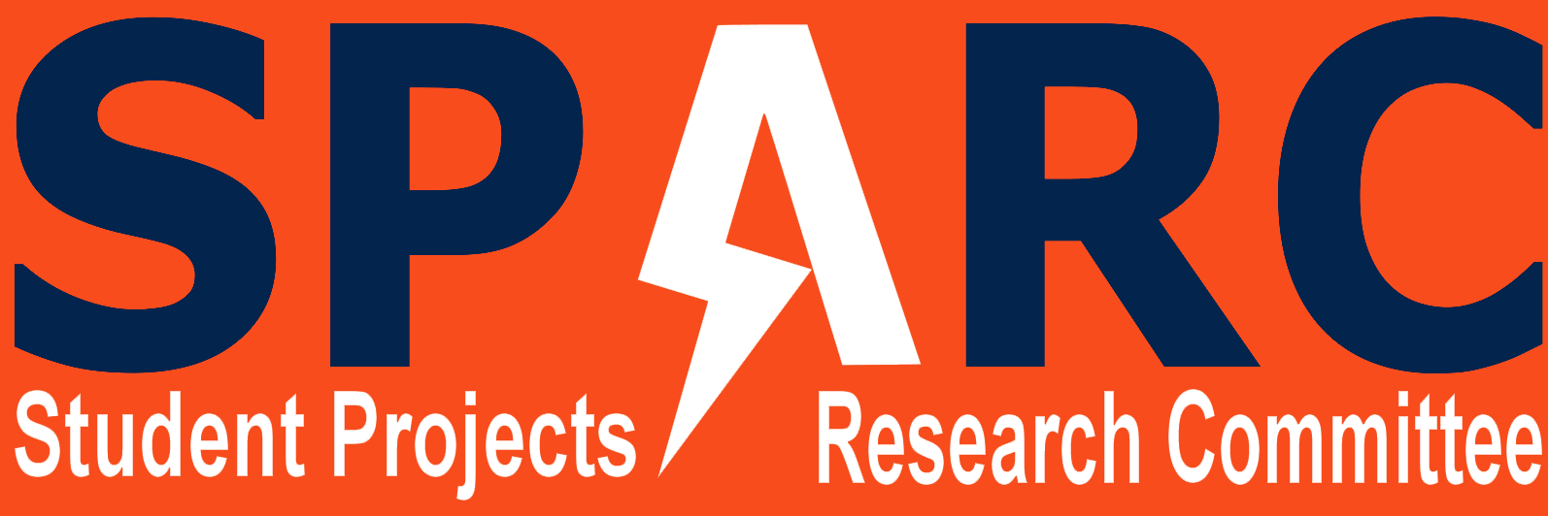

**Purpose:**  
SPARC stands for Student Projects and Research Committee. It functions as Auburn University's makerspace. It was founded by the Auburn University Electrical Engineering Department in 2006 to provide students with the opportunity to test out their own ideas, integrate concepts learned in class, compete with peers at other schools, and demonstrate their products to the public. SPARC provides the lab space, tools, materials, and funding for projects. If a student pays for their own materials, they can even keep their projects.

Any Auburn University student undergraduate or graduate regardless of major or year can work on a project facilitated by SPARC. SPARC provides the opportunity for younger students to work with older students. It is a great way to get real problem solving experience and apply some of the knowledge that is learned in classes. It also serves as a great resume builder in which can help get members get involved in Undergraduate research and CO-OP’s and internships.

**Social Media**  
Website: <http://sparc-auburn.github.io/>

Twitter: <https://twitter.com/SPARC_Auburn>

Github: <https://github.com/SPARC-Auburn>

Facebook: <https://www.facebook.com/groups/ausparc/>

Youtube: <https://www.youtube.com/channel/UChy2Yfn_cgeQE6An8ifg5mw?ab_channel=SPARCAuburn>

Email: sparc.auburn@gmail.com

**Meetings:**  
Joining SPARC is really easy. Membership is free. All you have to do is log 5 hours in the lab (Broun 368) in order to familiarize yourself with the club. After that, you will be given 24-7 code access to the lab and building. SPARC usually formally meets once a week in Broun 256 at 6:00 PM on Tuesdays to review the status of the various projects and learn new skills. If you would like more information or are interested in joining please email us at: sparc@auburn.edu.  
  
**Projects, outreach, competitions, conferences, etc.:**

SPARC is always working many different projects at a time. Many of our projects involve robotics, 3D printing, quadcopters, and research. SPARC also participates in several outreach events to teach young students about STEM. SPARC always gives a large demonstration every year for E-Day. SPARC also helps with university research projects.

**President/Captain:**  
Steffen Sullivan  
sbs0034@tigermail.auburn.edu  
  
**Advisor:**  
Thaddeus Dr. Roppel  
roppeth@auburn.edu  
  
**Category:** Professional, Competition   
**Related Major:** All Majors